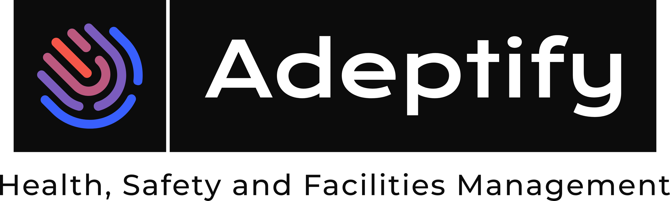 | Harlyn Primary School
Health and Safety Update for Governors 24th January 2024

Completed Tasks Since last Meeting.

Task | Status | Task Owner
Outstanding action from LBH audit | Complete – September 2023 | Adeptify Ltd
Reviewed and updated all statutory Risk assessments. | Completed – Monthly Rolling Review Ongoing | Adeptify Ltd
Review and Update Emergency Evacuation Procedures | Reviewed & Completed | Adeptify Ltd Headteacher
Drafted Emergency Preparedness, Disaster Recovery and Business Continuity Plan | Reviewed & Completed | Adeptify Ltd Headteacher
Lockdown Procedure | Reviewed & Completed | Adeptify Ltd Headteacher
Fire Risk Assessment | Completed in November 2023. Remedial Actions Issued December 2023 | Adeptify Ltd
Fire awareness for Fire Warden Training | Issued and completed for additional Fire Warden | Adeptify Ltd Headteacher
Fire Risk Assessment – Remedial Actions | Ongoing | Adeptify Ltd  Headteacher  Site Manager

