SITE MANAGER REPORT JANUARY 2023
SUMMARY OF MAINTENANCE ACTIVITY SINCE THE PREVIOUS MEETING
Update on issues raised at last meeting:
Point Raised | Progress
Hall Roof Leaking: | Leak has been stopped but still waiting for the Borough to confirm liability for the repair.
Water seeping in Nursery Playground | On hold until next FY
Corrosion Nursery canopy supports | Have arranged for a company to provide a quote for work in summer holiday.
Significant Non-scheduled Repairs
An under-sink Ariston water heater split over the bank holiday weekend of 17-19 Sep and leaked hot water causing significant damage to 4 classrooms. The borough advised that the maximum claim for insurance was £25k with a £200 deductible per item claimed for. Duncan completed as much of the work as possible to keep costs down with contractors used for the electrical, plumbing, decorating and some building repair work. A specialist company was used to replace the ceiling tiles in the corridor as the existing tiles sizes were no longer available so a new suspended ceiling had to be installed. The tiles in the classrooms were replaced by Duncan.

From this incident we found that the isolation valve for the water supply in the East Building bottom corridor classrooms is behind a panel fixed with 6 screws so not readily accessible. Valves have now been fitted to each classroom and Duncan will hinge the panel to turn it into a door to make it accessible.

As a precaution the under-sink water heaters are now isolated at the distribution board panel over weekends and holidays.

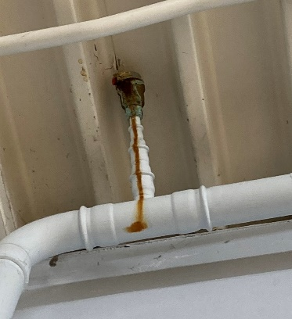
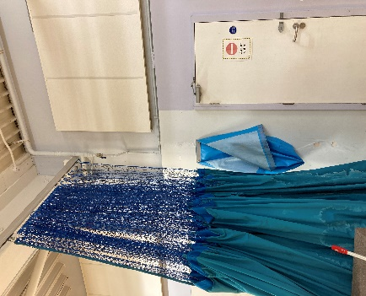
The automatic bleeding valve for the old heating system in the East Building which is fitted high up in the hall developed a leak and was replaced. This seems to have cured our problem with air in the radiators which were previously being bleed weekly.
Breathing Buildings conducted a 100% check of the East Building hybrid ventilation system and established that it had not been installed correctly! It was not done directly by them but was installed by the builders. We may be able to fix it by running a data cable from the control panel in the West Building to the first node in Class 1P when we can afford to do so.
Scheduled Work Completed
The netball courts have been re-marked. | Gas Safety inspection
Fire Dampers service | Lifts service
Aircon service | PAT Testing
Gym Equipment Safety Inspection | Kitchen equipment service
Alarms serviced | Boilers and pressure vessels inspected by Zurich
Play Equipment inspected by creative Play | Zurich tested boilers and pressure vessels

Attached: Photos of Water Damage to Classrooms as ZIP file.

