Premises Meeting 24 May 22
Update on issues raised at last meeting:
Point Raised | Progress / Target Date
Blocked drains on roof | Cleared
Water seeping in Nursery Playground | Obtaining quotes for Summer Holiday repair
Corrosion Nursery canopy supports | Obtaining quotes for Summer Holiday repair
Nursery shed roof leak | New Felt to be fitted scheduled for May Half Term
Concrete at shed entrance | Work underway
Sprinkler building water leak into base | Scheduled for Summer Holiday repair
Sprinkler Compound Fence painting | Scheduled for a Summer

New Issues
West Building Hot Water Boiler is broken again this time because of a corroded fan caused by the previous leak | Awaiting spares
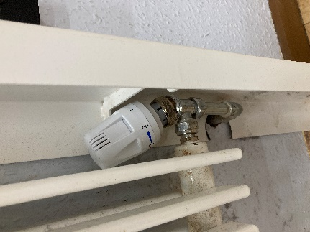  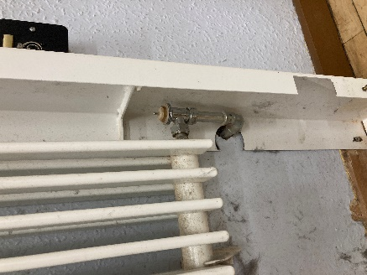  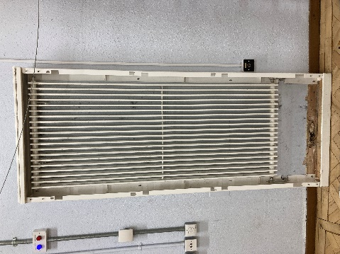  Radiators – The Hall radiators are not fitted with thermostats because the casing fits too close to the valve. | Site manager to cut out casing and fit a valve to each radiator.
Sprinkler Compound fence damaged by high winds | Awaiting repair by Barnes Fencing

Ongoing Issues
- Vynyl lifting on stairs
- Carpet which had been stuck down with tape has now been glued time will tell if this proves to be a long-term solution.
- Harlyn Garden fence was temporarily repaired after the high wind and a quote has been requested for a replacement.
- The Pond – Clearance of debris has been hampered by the condition of the decking which is badly rotten.

