PSHE Monitoring Report for Governors – Autumn Term 2024

The PSHE monitoring undertaken in the Autumn Term 2024 focused on:
- Evidence of PSHE teaching and learning
- Progression of skills across the school
- Planning, including medium term plans (MTP’s)

PSHE lessons across the school were observed. Teachers completed questionnaires relating to the teaching of PSHE.

The findings of these are summarised below.

Observations

Strengths
- All lessons observed from Year 1 – Year 6 matched the MTP’s
- Lots of pupil discussion
- SEN children present in most PSHE lessons observed, eg. this is not missed due to interventions etc.
- Cross curricular links – Y5 linked to computing using the iPad to find something that represents being unique, Y4 linked to English through ‘the heart and the bottle’ book
- Some links to progression of skills/revisiting being taught eg. Year 3’s lesson was linked to year 1’s lesson taught in the same week – helping each other, working as a team
- Links to other areas of PSHE within a lesson – eg. Year 6 linked to zones of regulation
- Across the school, class room displays also evidenced PSHE learning e.g. Class Charters, Zones of Regulation, children’s targets/goals, Merit Certificates, PE Superstars.

Areas for improvement
- During the observations it was unclear and difficult to find links to the progression of skills being taught
- Consistency with teaching/planning eg. some teachers use f/charts, some use Twinkl planning, some use PowerPoint
- Consistency across the school regarding evidence – KS1 do not have books or folders for PSHE and often complete activity sheets, KS2 use books for every lesson

Feedback from Teachers

Below is a summary based on the feedback from teachers through a questionnaire.

Teacher responses highlighted that teaching and learning styles for PSHE lessons continue to be varied and provided a different way of learning from those teaching methods utilised for core subjects.

Lesson times per week across the school vary from 30 – 45 minutes. On the whole, PSHE is consistently taught each week however it is usually the subject that gets dropped from the timetable for rehearsals, concerts, visitors etc and finding time to catch up on this is challenging.

Evidence kept of the pupils’ learning varies across the school. KS2 use the work recorded in their PSHE books as evidence. Whilst KS1 put some of these sheets in a folder, not specifically for PSHE. Teachers have said that this evidence is not really helpful for assessment, it is more kept “just in case”.

All teachers stated that a scheme would be very useful. This would support teachers with feeling more confident to teach PSHE and ensure progression.

Medium Term Plans

Prior to the inset day, I reviewed the MTP’s and whilst looking through the curriculum map, the 3 themes: Health & Wellbeing, Living in the Wider World and Relationships were not clearly visible.

I reviewed the planning across the school and categorised planning from each term in each year group under the 3 main themes.

On the inset day, we reviewed the MTP’s and curriculum map and discussed with class teachers to ensure that the theme that had been allocated per term, matched what was being taught.

This also enabled me to clearly see if all 3 themes were being taught across each year group. Please see below.
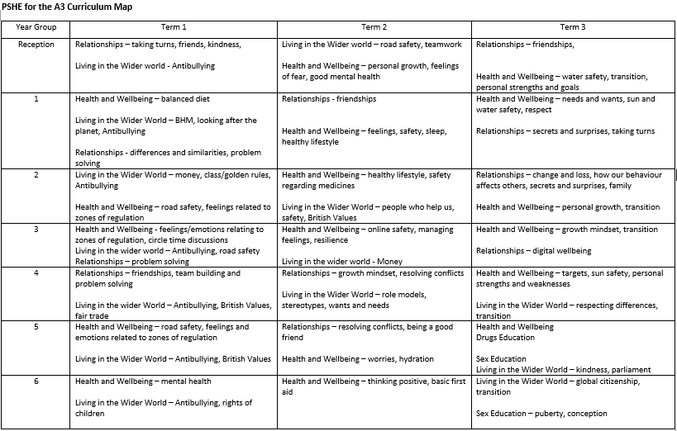

Next Steps

Based on the feedback from Ofsted, feedback from teachers and the findings from my monitoring, I think it will be beneficial to implement a scheme to support teachers with their planning, ensure that the progression of skills is being taught and to allow for consistency across the school.

I am currently trialing 3 new schemes, called Kapow, Jigsaw and Brook’s PSHE Curriculum. Based on how these go, I would like to find one that suits us the best and implement it across the school.

One of the schemes (Brook’s) teaches the progression of skills in 3 lessons per term. This allows teachers the flexibility to use the other 3 lessons to teach lessons related to the time of year, or as situations arise in class etc. Teachers can use the scheme as a starting point, and adapt it as they wish.

I am also trialing the use of floor books in Year 2 for PSHE, please see below some images of this. During my subject leader course which I attended in the Autumn term, I was able to discuss with other teachers at various different schools how PSHE is taught and evidenced. A lot of these schools use floor books across KS1 & KS2.

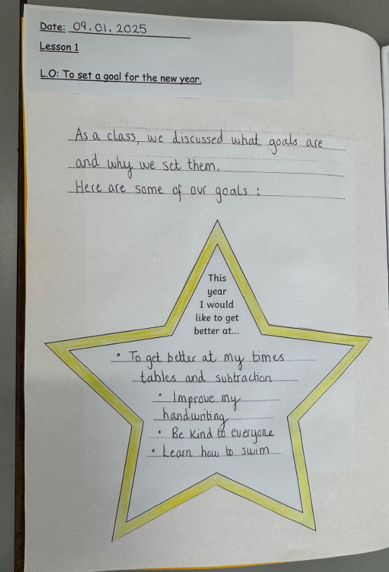
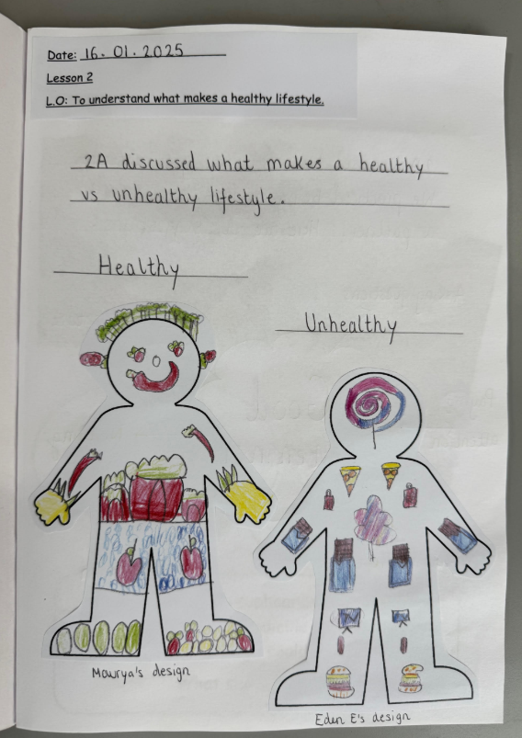

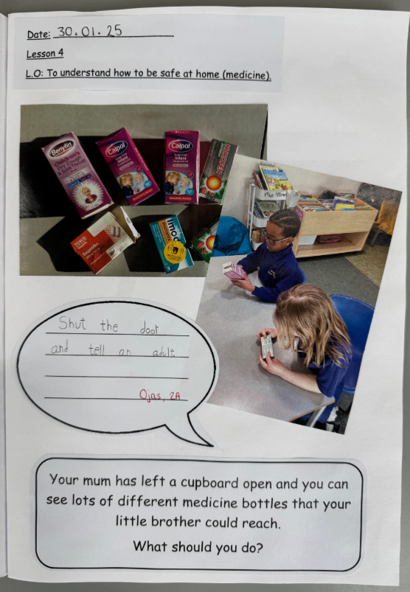
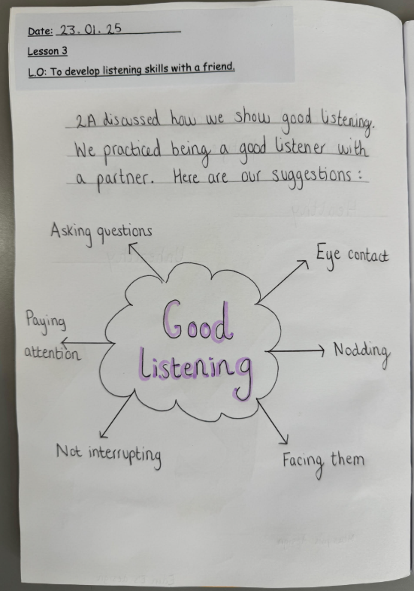

I would then like to introduce this in KS1 as a way of keeping a record of the lessons that are being taught, alongside the progression of skills in a clear and concise way. This could then be something to consider using in KS2.

This would enable consistency across the school and remove the pressure for teachers of completing activity sheets and written work for each lesson as evidence, allowing PSHE to be more discussion based and relevant.

It also enables the teachers to be as creative as they like or feel confident to do so. Children could also be given the responsibility of helping to record ideas from the lesson in the floor book.

Report by Bethlyn Allmey
January 2025

