REVIEW OF MUSIC AT HARLYN PRIMARY SCHOOL JANUARY 2020 MR D.P CONLAN

Curriculum
The music curriculum follows the guidelines at set out by the Incorporated Society of Musicians in 2019. This includes an emphasis on:
*Singing, playing a range of instruments, and using appropriate music technology.
*Listening
*Performing
*Improvising
*Composing
*Learning by ear
*Musical notation
*Whole class ensemble teaching (First Access/Wider Opportunities)
Critical engagement and a new title Social Moral Spiritual and Cultural (SMSC)

Planning:

Foundation Stage

We relate the musical aspects of the children’s work to the objectives set out in the Early Years Foundation Stage Curriculum. An emphasis at this stage is on learning to sing with control and increasing expression, and the resource ‘Singing Phonics’ Books 1& 2 are a useful resource for this. Pupils begin exploring beat and rhythm using untuned percussion, and begin to be aware of the self-discipline required to cope with the distinct demands of this practical based subject, taking place outside their normal classroom environment.

KS1 and KS2

The basic area of musical activity- performing (including singing and using instruments) composing (organising sound and silence) listening and appraising are given equal weighting in each term and where possible are related. In particular, some aspects of listening and appraising will form an important part of every music lesson. The majority of lessons have a practical starter to engage pupils musically and immediately. Long and Medium Term planning is mostly cross - curricular topic based, following the knowledge, skills and understanding as set out in the National Curriculum, and written by the Music Co-ordinator. The schemes are progressive and so children are increasingly challenged as they move through the school. Planning is well differentiated and regularly evaluated by music co-ordinator ensuring it remains relevant and challenging to all pupils. Please see a copy below for long term planning from September 2019.

MUSIC LONG TERM YEAR PLANNER (from September 2019)
Class | Autumn 1 | Autumn 2 | Spring 1  Jan- Feb | Spring 2  Feb-Apr | Summer 1  Apr-May | Summer 2  Jun-July
R | Introduction to music.  Singing simple songs with actions  Basic Rhythm skills on untuned percussion.  Basic Singing skills | Christmas | Singing Phonics3  Songs & Movement | Untuned Percussion  Keeping the Beat | Songs & Movement  Song stories | Summer Topics
Yr 1 | Introducing the elements of music. | Christmas | Graphic Scores | Toys | The Sea | The Sea
Yr 2 | Elements of Music- Duration  The Long and Short of It.  Haunted House | Christmas |  | African Music  African drumming
—  Yr 3 | The Orchestra  The Weather | Music and Egypt patterns and Graphic Score. | Rounds  Songs and Music about the Romans | Carnival of The Animals  Glockenspiel & xylophone skills |  | Glockenspiel & Xylophone skills  Summer Concert preparation
Yr 4 | Music and Brazil | Recorder skills  The Tudors- Medieval music and  Fanfares- composing a fanfare.  (Ongoing)Tin Can rhythms and notes on the treble clef | Scales & Melodies incl  The Tonic Solfa. | Baroque Music & Recorder Skills | Keyboard Skills | Rap Songs  Summer Concert  Preparation
Yr 5 | Music and The Victorians | Music and Space  Christmas Activities | Structure= Binary, Ternary  And Rondo Form.  Compose a piece  Water | Blues Music  Incl composition.  Keyboard skills. | Film Music  ICT | Recorder Skills  Summer Concert preparation
Yr 6 | World War 2 music | World War 2 Music  Christmas Activities | Ukulele | The Beatles  Keyboard skills | Songwriting  ICT | Drumming Skills  Summer Concert preparation

Assessment

Following guidance from the Incorporated Society of Musicians (ISM) following a review in 2019, and also using a Progression of Skills in Music Chart written by Gareth Webb, a school support consultant, progression of skills has been streamlined, and is shown below:
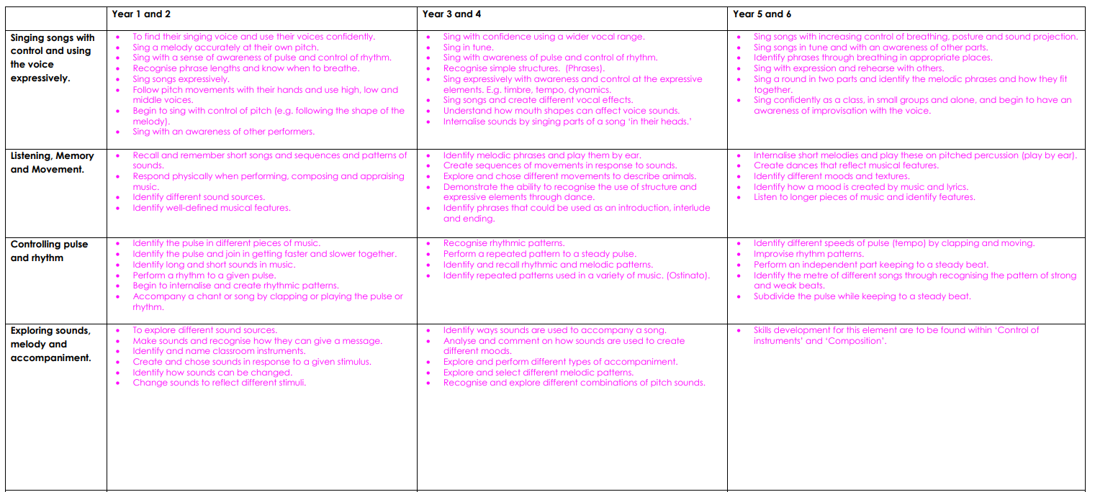
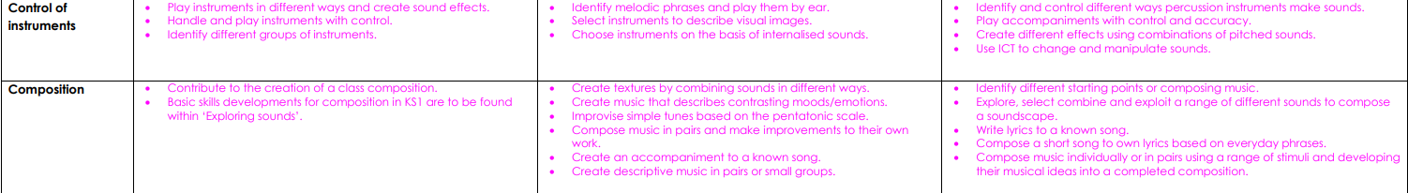

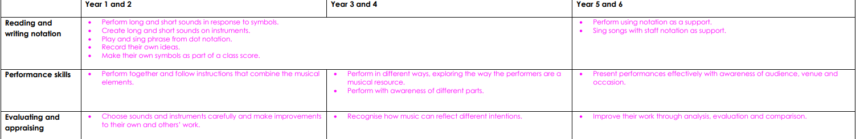

This grid is used against the child and assessed in the normal way as is conducive to Harlyn, (working towards, at or beyond)

Overall review of Monitoring Autumn 2019
*Children continuing to learn a tuned percussion instrument at KS2 (glockenspiel in Year 3 and recorders in Year 4)
*The keyboard is introduced at the end of Year 4 and is continued until the end of Year 6.
*In January 2019, I began teaching ukulele for the first time to Year 6 with a suite of ukuleles provided by the FRA. This has been very enjoyable for the children and some even played at our summer fair in 2019.
*Singing continues to play a major part of classroom teaching using song and lesson activity content from the Sing Up website. The school achieved a silver award for singing in 2018 from the sing up organisation which was a fantastic achievement.
*Music ICT has been integrated well. The children are now familiar with the Charanga website and enjoy using it to learn a plethora of instruments. This proved a really effective way of teaching children about the elements of music and also a fun interactive way of learning to play the glockenspiel and recorder. The children have also been enjoying a full suite of musical keyboards.
*The school choir continues to flourish, albeit with slightly fewer numbers. This is due to conflicting clubs taking place at the same lunchtime.
*A new orchestra was formed in September 2019, as there was a huge loss of successful Year 6 children. They are coping well with new material and performed successfully at the Christmas concert.
*In December 2018, and then in December 2019, twenty Year 5 and 6 choir members sang some Christmas carols at High Meadows, a local care home. This is part of an idea to increase links with the local community. It has been a successful project so far and it is hoped that we can continue this every Christmas now.
*In April 2019, the choir attended for the first time a festival at Brunel University where we sang a number of songs on stage with other schools and also on our own. We are now famous on Youtube!
*The choir continued to enjoy the Northwood Hills Switching- On lights Ceremony and the Christmas concerts.
In July 2018, the music room was furnished with surround sound speakers.

Periapetic teaching from September 2019
Number of children learning the following instruments:

Keyboard | 26
Guitar | 12
Violin | 8
Clarinet | 3
Cornet | 3
Flute | 2

Therefore, a large increase in Peripatetic teaching from the time of the last report.

Objectives for remainder of 2019-2020
*To ensure that high quality music class provision continues.
*To incorporate more ICT into music, beginning with the purchase of an Ipad, in consultation with the ICT manager.
*To replenish older instruments in the music room
*To partner with a number of local primary schools and forge links with a local secondary school to create and perform music together, and to share ideas with these schools in relation to planning and curriculum.
*To chair a meeting of local primary schools and discuss music at the learning network.

