PSHE Monitoring Report for Governors – June 2022

The PSHE monitoring undertaken in the Spring Term 2022 focused on:
- Evidence of PSHE teaching and learning
- Progress made with implementing the revised RSE curriculum

Pupils and teachers completed questionnaires to reflect their views about these areas.

The outcomes of the Pupil Voice and Teachers’ view are summarised below.

Feedback from Children

Across the school from Years 1 - 6, children continue to enjoy learning in their PSHE lessons through role play/drama, discussion and group work, making posters, circle time and problem solving.

Children continue to learn about safety e.g. stranger danger, road safety and E-safety.

In addition, PSHE lessons provided an opportunity to discuss and increase awareness about the Unicef Right and Respects for Children.

From the responses below, it is evident that children are thinking about their learning from the PSHE lessons and applying their knowledge to everyday situations.

Quotes from children:

Year 1 - “Anti-bullying.”
Year 2 - “Anti-bullying.”
Year 3 - “PSHE helps me to keep safe when crossing the roads. I know not to cross the road when the light is red.’
Year 4 – “PSHE helps me to keep safe and how to keep others safe. It helps me to know how to be healthy and to be kind.”
Year 4 – “PSHE helps me to keep safe and how to keep others safe. It helps me to know how to be healthy and to be kind.” “PSHE helps me to know what to do.”
Year 5 – “Staying hydrated”

Children’s suggestions for PSHE learning:
KS1 reported they would like “more PSHE” and use “drama and role play” to support their learning of PSHE.
KS2 reported that they would like more drama and discussion opportunities.

Feedback from Teachers

Teaching and learning styles for PSHE lessons continue to be varied and provided a different way of learning from those teaching methods utilised for core subjects. They helped provide a more balanced way to access the PSHE curriculum and increased opportunities for promoting pupil voice by sharing their thoughts and ideas.

Other ways that teachers incorporated PSHE into their daily learning was through the:

Zones of Regulation
Worry Monster
Mixed Up Mondays (children are encouraged to play with someone different)

Teacher responses highlighted how the key areas of the new RSE curriculum had been added to teaching to develop links to other subjects in the curriculum e.g.

- Marriage - RE
- Friendships
- Happiness
- E-Safety (Computing)
- Bullying (Anti-Bullying Week)
- Secrets and Surprises
- Different Family structures
- Respecting different types of families
- Solving problems

Evidence for Learning

Evidence of children’s PSHE learning in KS1 PSHE learning was recorded on sheets in folders.
In KS2, children record their PSHE learning as a separate section in their RE books (at the back of the book).
Across the school, class room displays also evidenced PSHE learning e.g. Class Charters, Zones of Regulation, children’s targets/goals, Merit Certificates, PE Superstars.

Teachers also provided examples of where opportunities for the Unicef Rights and Respect for Children had been integrated into PSHE learning.

- In the Early Years, through play, references made to Articles 31: Right to play and relax, (playtime behaviour) and Article 28: the Right to education.

- Class assemblies focussed on rights, e.g. Article 24, the right to water/health/education

- RE – Article 30: Right to culture

- History – Article 12: during discussions the right to speak/also to resolve disagreements

- Article 24: Healthy diet

RSE

On the Inset Day (22.10.21) we viewed medium term plans, classroom displays and books.
There is evidence of aspects of the new RSE curriculum being taught across the school. We are able to offer additional support to continue embedding this further.
Our vision is for children to develop a deeper understanding and respect for relationships.

Report by Ambarine Payne and Shruti Mistry
June 2022
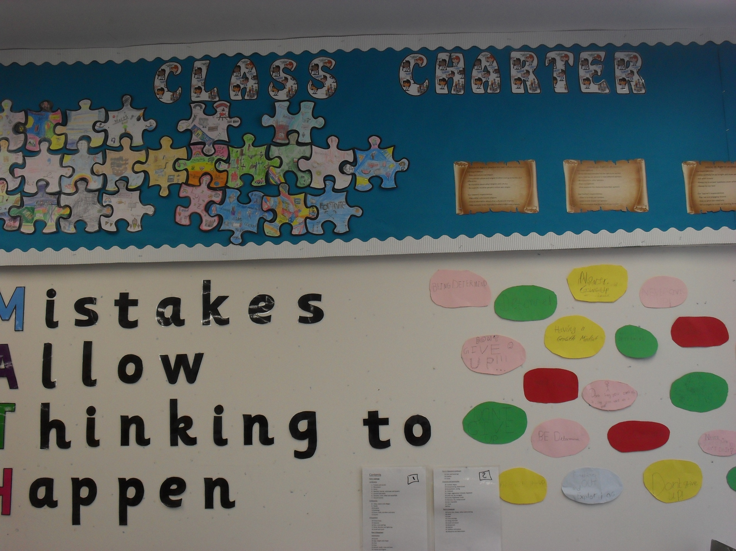
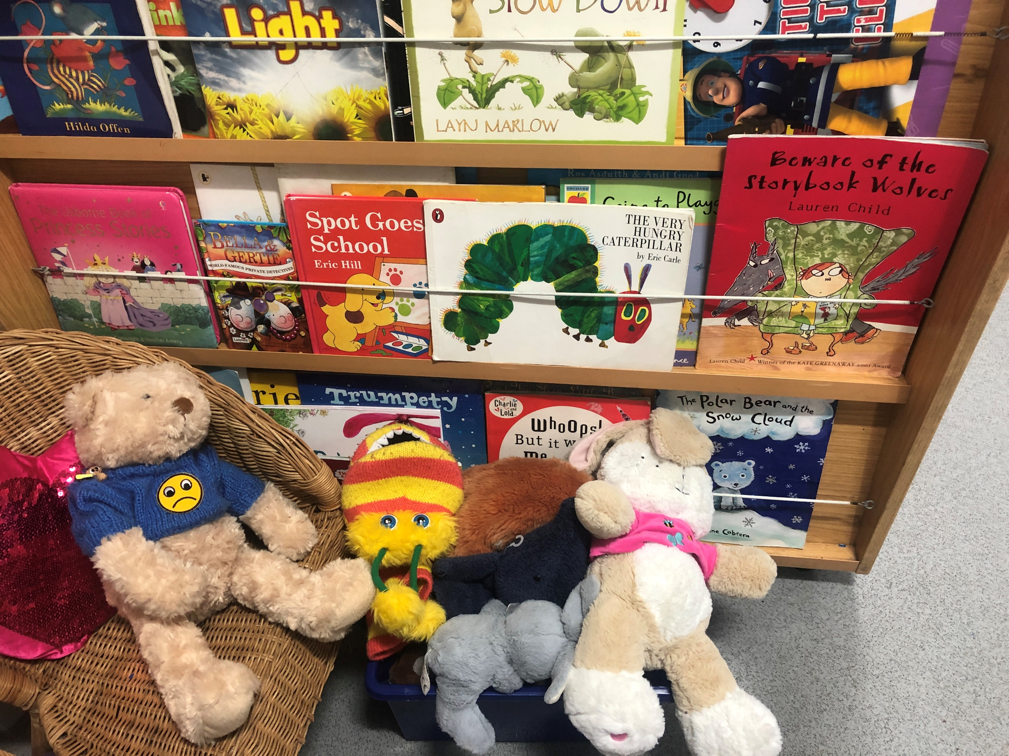
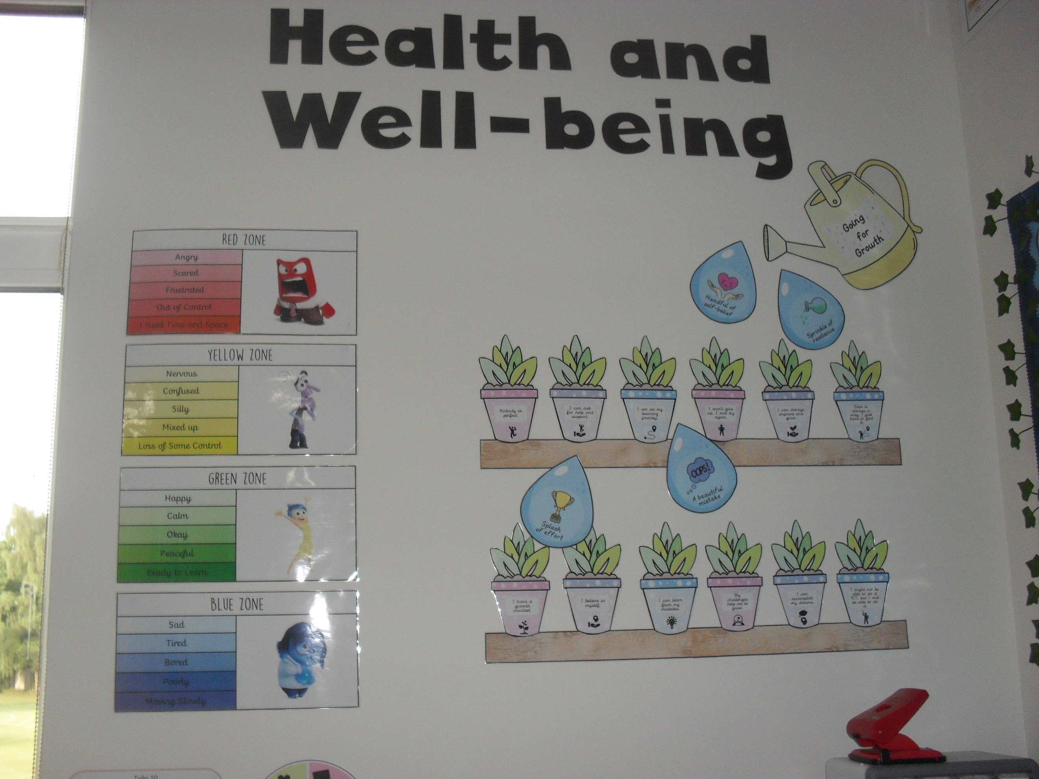
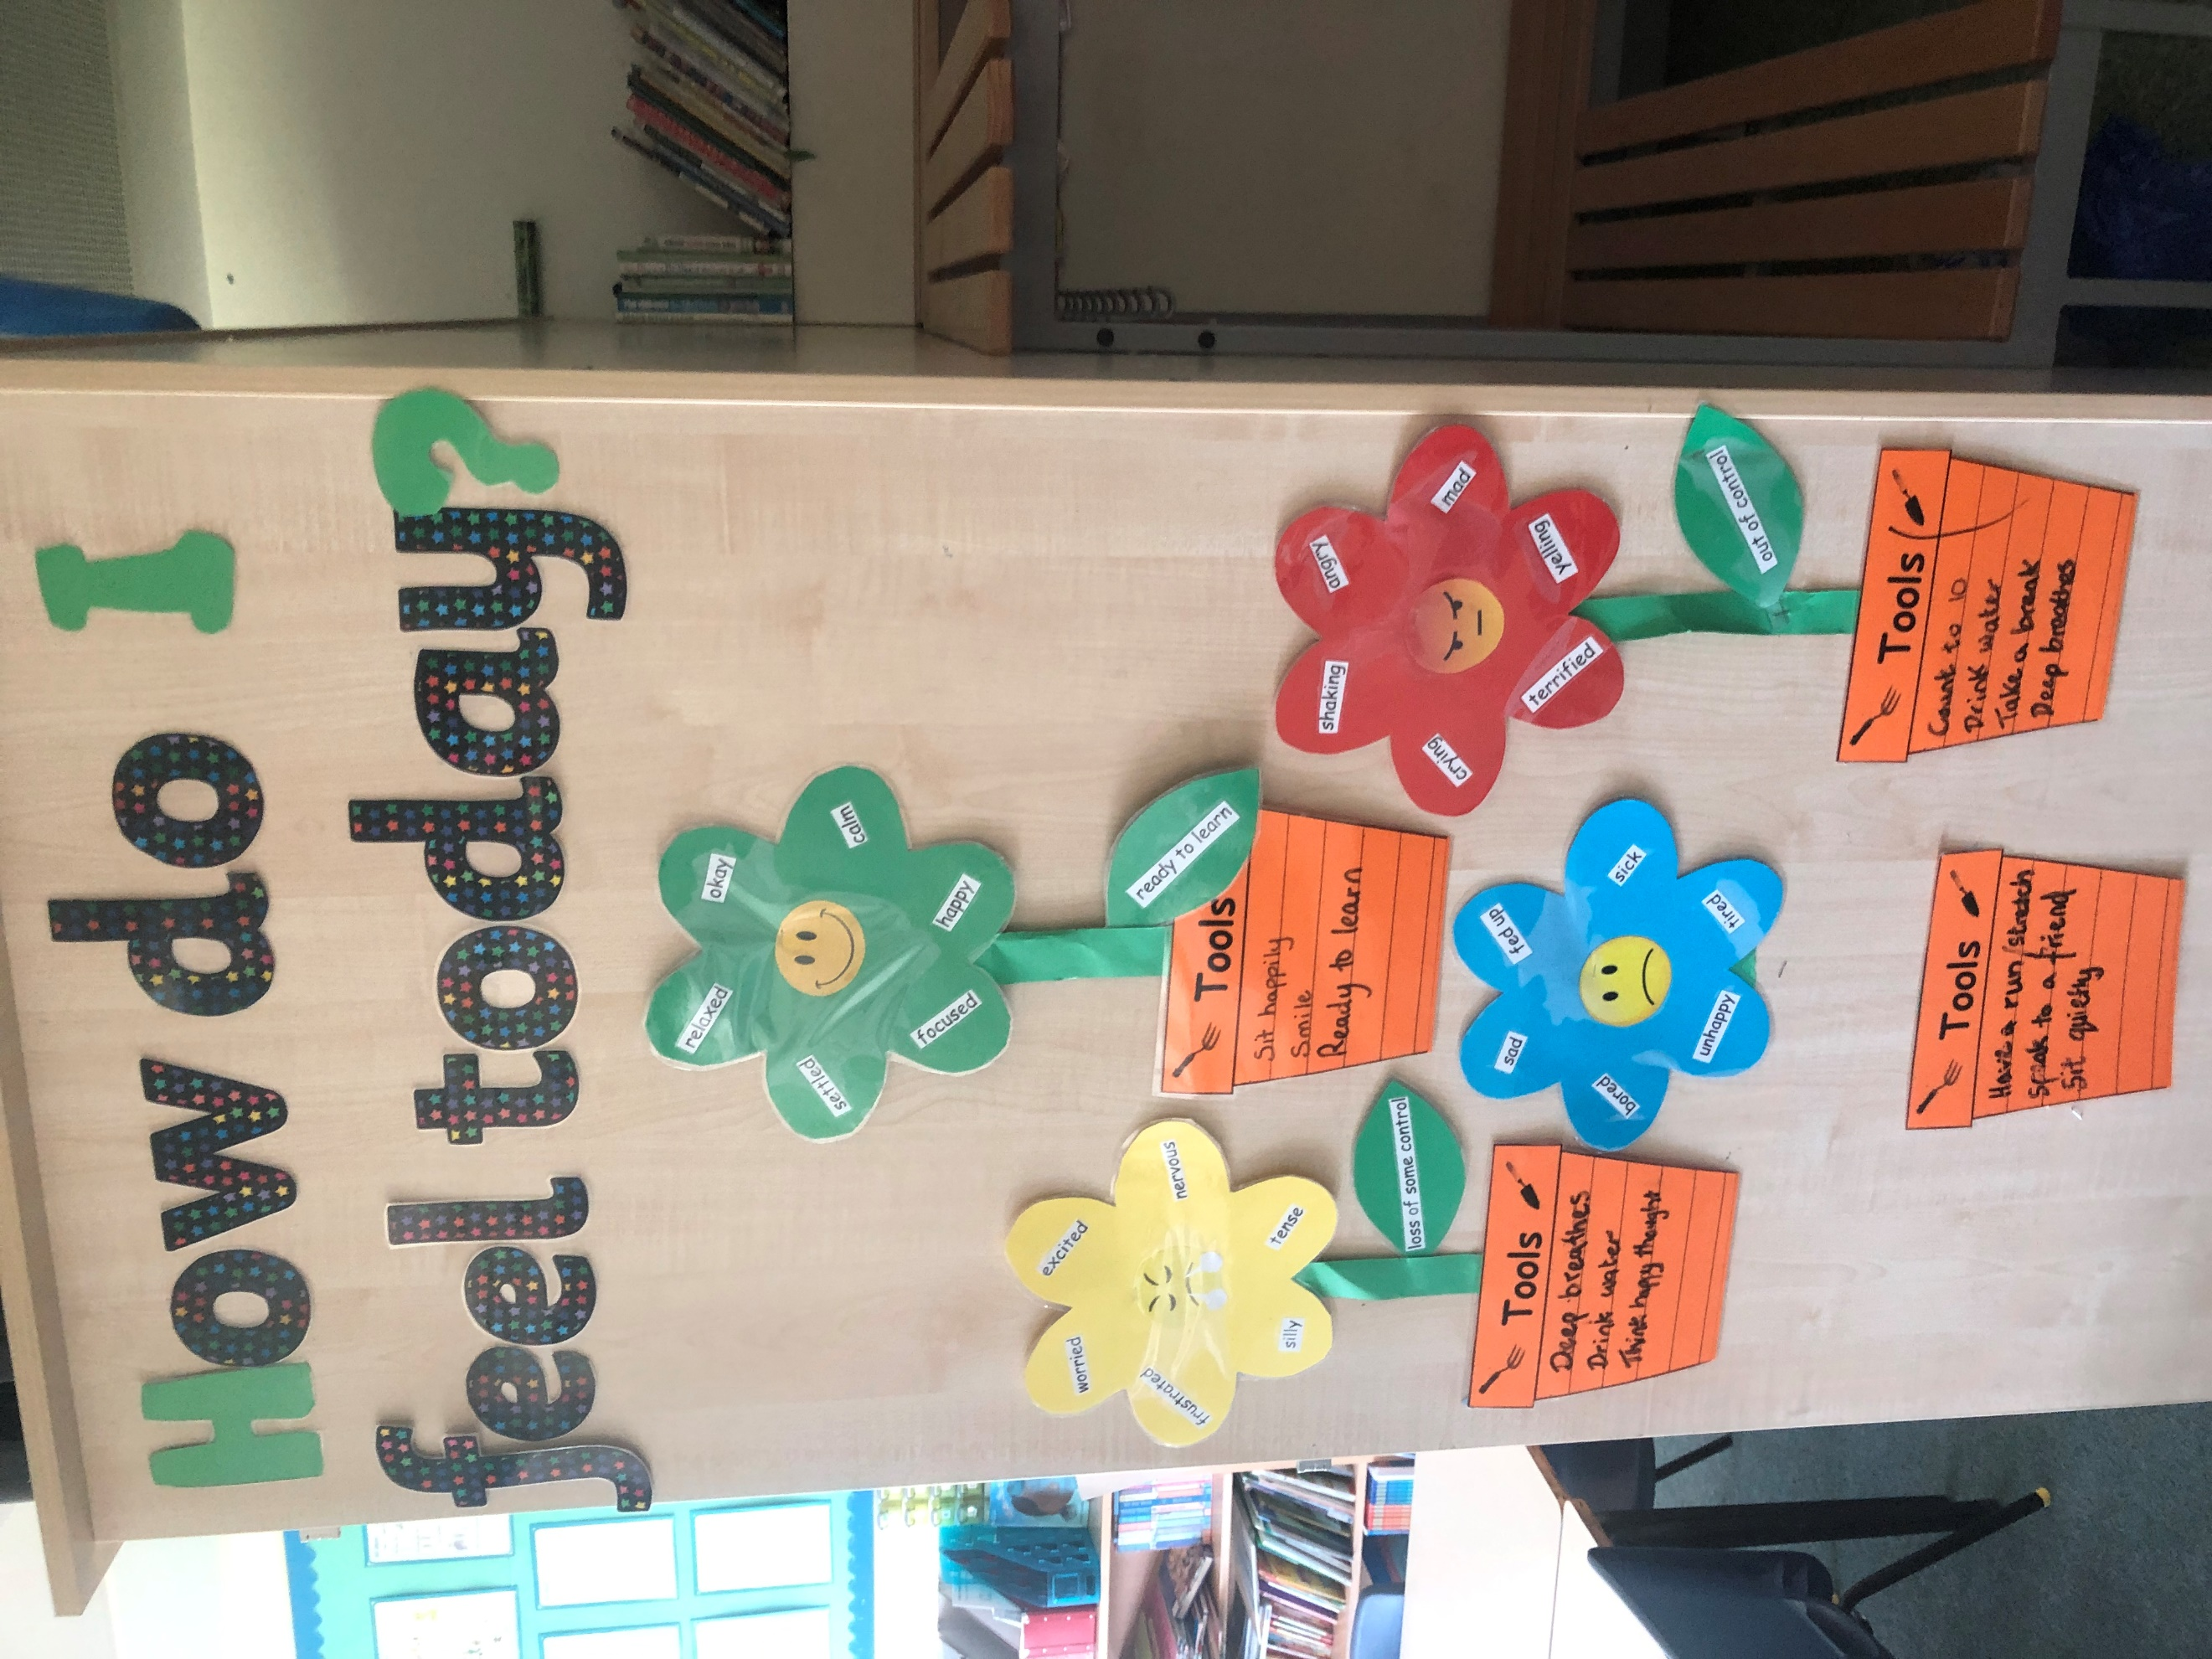
LKS2
UKS2
KS1
EYFS

