Inclusion Report for the Governors – May 2024

This term our focus is on supporting transition particularly Year 6 as they plan their onward journeys to Secondary Schools and on any new intake to our Nursery and School. We will also be offering all our support to Year 6 for the pending SATs week.

Personnel: -

We are in a difficult situation in that a member of staff has had to have a further operation and as a result a minimum of 6 – 8 weeks off for her recovery. This is the 4th time over the last 18 months and has been really disruptive for our children with SEN. It has also been challenging for the staff that are continually moving classes to ensure support is in place especially for the children with more complex needs.

Once again we were unsuccessful in recruiting a SEN TA and so are currently hiring an agency member of staff.

I still believe that we should try advertising for part-time staff as I am certain we would have more applicants of better quality. Out of the 24 children with EHCPS that we currently manage, only 3 of them have full-time funding.

We have recently learnt that Kim Carvell, our Play Therapist/Pastoral Care Assistant is retiring at the end of this year. This will be another huge loss due to the high quality play therapy skills and excellent pastoral care that she so naturally and skilfully applies. She has supported so many children, families and staff over the years with their emotional needs. Even more than 2 years Post Covid we are still seeing the impact of children being comfortable to learn at home and struggling to come to school. There is always a huge welcoming party on the playground in the mornings (Kim being part of the welcoming party) aware of children that need TLC and extra support to encourage them to come into school.

Training: -

Last month, Kate Turnell and Shai Malik attended a training on “Anxiety and Girls” with some links as to “Understanding Girls and Autism”. Dr Reynolds, EP delivered the training and the feedback was very positive commenting on how informative it was.

Michele Hughes and Shai Malik has just started a 10 week ELKLAN training. They will learn all about supporting our children with Speech, Language and Communication from the ages of 5 – 11.

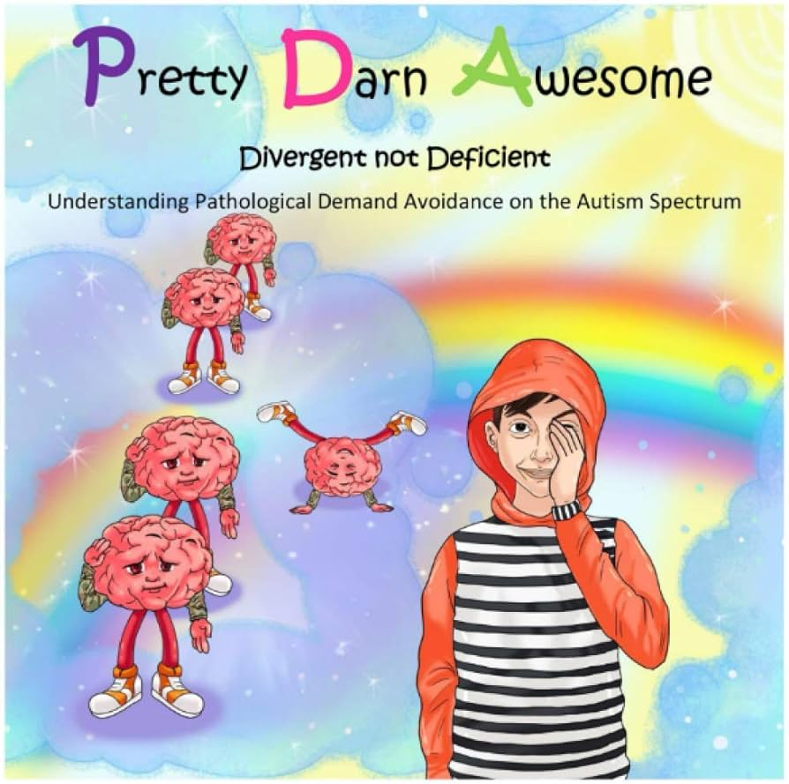
I have recently spent half a day supporting a SENCO from a local school with exploring successful EHCP applications.

Simon has held a Support Staff training to share the new School Development Plan. We also listened to a child’s story about Pathological Demand Avoidance titled “Pretty Darn Awesome” to help our staff understanding why some of our children struggle with the daily demands of learning.

Rachel Penny, Speech and Language Therapist has offered school the following training: -
1. Intensive Interaction for Nursery staff
2. Whole Class Communication strategies for all staff.
3. Selective Mutism for Support staff.

Successes: –

We have been successful with 3 more final Education, Health and Care Plans.
This brings the current total number of plans to 24. We are awaiting the outcome of 3 more Education, Care, Needs, Assessments that were completed this year; 2 of which have passed the initial panel with a “yes to assess”. If all 3 are successful we will then have a total of 27 EHCPs. I believe this is the highest number that we have ever had, once again highlighting the high level of our children with additional needs, some quite complex and challenging.

We have applied for Early Support Funding for a Year 2 child and a Year 3 child.

We are also applying to renew funding for 2 children, hoping that the funding will be allocated again for another year. You can renew Early Support Funding 3 times.

Challenges: –

It is proving challenging to ensure there are sufficient staff to support our children with SEN and this is the result of staff absent with long term sickness.

We continue to receive Consultations requesting for our school to offer places to even more children with EHCPS and often with complex needs. These consultations are where a Parent requests for their child to come into a Mainstream environment or are a Borough placement as there are no Specialist School placements available.

We are working hard to make sure that we have all the paperwork, including a My Support Plan, in place for our children in Nursery that are transitioning to Reception in September and will require high levels of support.

Heidi Ivory, Kim Carvell and I continuing to support in Nursery due to the high levels of children with more complex needs.

Monitoring: -

Our SEN Register is consistently updated.

Part of the SMT monitoring cycle has been to check the EHCP support in class.
This helps us to ensure that all the children with plans have the correct level of adult support, the learning is adapted to ensure access for all and that the children can meet their full potential.

Future: -

- We are continuing to plan the activities for our “Celebrating Differences” focused week in the summer term.

- We will be holding a Chat, Share and Cuppa Parent Meeting for our Parents with children with ASC and ADHD.

- We are considering working towards an accreditation for the Young Carers.

- We will be sending a member of the Reception staff to attend the Language Link Champion network event/training this month.

Thank you for taking the time to read my report and please do not hesitate to contact me should you have any questions.

Sarah Tosdevin, Inclusion Manager – May 2024

