Harlyn Primary School
Assessment Report to Governors
Autumn 2017
Overview
With the introduction of the new National Curriculum in 2014 and its new statutory assessment regulations, Harlyn has successfully implemented revised teacher assessment and pupil tracking tools. During the transition period in ‘life without levels’, I have ensured that the new system continues to be effective and robust, is understood by all stakeholders, is fit for purpose and data is used to promote learning.
Since autumn 2015, all year groups have been using the whole school points tracking system to assess children against the key objectives of the new national curriculum in reading, writing and maths.
Leadership and Management
I have undertaken a range of leadership and management activities to ensure that data is used to inform teaching and learning, the allocation of resources including personnel and supports whole school improvement. This has included:
- Training:
Staff have been trained to enter class data directly into SIMs (School Information Management system). Prior to this teachers were entering data onto an excel spreadsheet and then I would manually enter this data into SIMs. This was not only duplication of teachers work but not effective use of my time. Teachers can now use the data entered into Sims to calculate attainment and progress of groups with increased accuracy at the click of a button. This has resulted in both reduced teacher workload and improved ownership of data.
- Termly pupil progress meetings formalised
I introduced a pupil progress meeting template for teachers to complete with key information relating to attainment and progress of groups, impact of interventions, targeting of individuals and groups and their next steps. Meetings are now more formalised and structured, resulting in greater rigour and accountability for progress and attainment. From this term (autumn 2017) staff have been informed that Simon, Sarah T and I will be attending pupil progress meetings alongside the phase leaders to support with the ‘drilling down’ on class data and the formulation actions.
- Reports to governors
To support governors in their role in holding the school standards to account I revised the attainment and progress tracking sheets to give greater clarity of progress and attainment over the year for each year group. This has enabled governors to identify patterns and trends in subjects in addition to year groups.
- School cluster moderation
Moderation of writing was undertaken alongside local cluster schools to monitor the quality of marking and feedback of children’s written work and the accuracy of teacher judgements on standard achieved. Feedback from schools in the cluster is that our judgements on attainment was ‘high’ compared to other schools in writing. We have decided to maintain our high expectations.
- Assessment time line and dates
I introduced an assessment time line detailing key dates in the year when assessment is due. This has been received positively by teachers. One teacher stated ‘I’m more aware when assessments are now due and so can be more organised for the collection of data and pupil progress meetings’. This in itself supports staff well-being and teacher workload.
- End of year pupil reports
As a leadership team, we have decided to introduce revised end of year parent reports from this academic year (2017/18). It was felt the new reports would give parents a wider knowledge of their child’s performance in the foundation subjects.
2017/18 Developing the capacity of staff
- Science subject leader
Science termly topic assessments to begin from autumn 2017. Prior to this, science assessments were undertaken at the end of the year. By teachers completing assessments on a termly basis, it will facilitate the early identification of gaps in children’s’ knowledge and skills, enabling timely intervention.
UKS2 Leader
I have worked closely with the UKS2 leader in reviewing year 6 teacher assessment tracking sheets for writing so that it reflects current DfE guidance. The government have responded to lessons learned last year and now teachers will have more flexibility in how they make judgements using the teacher assessment frameworks for writing.
- Reading – Analysis of KS2 SATs data showed that our lowest performing group is white working class boys, especially in reading. To engage this group, the year 6 team have reviewed current text and introduced new text to both inspire and develop their interest in books and reading for pleasure.
SMT
- In response to the outcomes of KS2 SATs results for reading, the SMT wrote an action plan for reading to address underperformance. Strategies include, whole class guided reading in KS2 with a focus on developing comprehension and inference skills.
- It was also agreed that all teaching staff be given a pupil progress performance management target with the aim of raising attainment across the school in reading:
‘To ensure that … of children in the class make at least expected progress in Reading by the end of year.’
Next steps
- Year 6 teachers to review/amend reading and maths tracking sheets to ensure parity with DfE guidance.
- Lead whole school change project - Effective Deployment of TA’s across the school. This will be data driven and involve supporting the SENCO in monitoring the impact of interventions (narrowing the gap for identified groups eg. SEN, disadvantaged).

Teaching and Learning
We use a number of assessment methods at Harlyn, both summative and formative assessments which are embedded into our practice.
- In years 1-6 maths and writing assessments take place every half term to support tracking children’s achievements against their yearly objective.
- Termly writing assessments are undertaken from Reception to year 6. These assessments are kept in pupil’s ‘grey book’ portfolios, as means of evidencing children’s writing progress
- The results from theses assessments, along with evidence from the books supports the teachers in making a professional judgment about where each child sits along the yearly bands in the schools tracking system. Tracking is updated termly and the results and the data is collated by myself and passed on to the SMT and subject leaders. Over the year I have unpicked the data and identified any focus classes or groups, this is then fed back to SMT. The focus classes for maths this year will be Years 2 and 5.
- Optional Tests in Y3 to 5 were introduced (summer 2017) to bench mark against our internal tracking system and to track year on year attainment for each year group.
- The results from these formal assessments are used by the teacher to inform whole class planning and teaching along with identifying areas for development for the whole class or specific children.
- Informal assessments are also carried out by teachers during the day to day teaching, this use of assessment for learning enables us to monitor the daily and ongoing progress of the each child. This is also supported by children’s books and children’s performance. This provides teachers with the opportunity to assess the children’s knowledge and to decide whether they have achieved the objective and are ready to move on, or if more consolidation is needed.
Developments
As a school we are continuing to develop pupil engagement in the assessment process by building pupil self-assessment strategies into our teaching as means of developing a growth mind-set amongst children. This includes:
- Providing immediate oral feedback that helps pupils to identify mistakes, correct errors and take the next steps needed to move their learning on.
- Use appropriate tasks that will provide us with quality assessment information by showing pupils' thinking as well as the answer
- Children self assessing their work (see photos Y2/Y4/Y6) -
- Growth Mind-set – Y3 children trailing use of effort grade (see photos – Y4 and Y6)

Examples of pupil self-assessment including effort grade

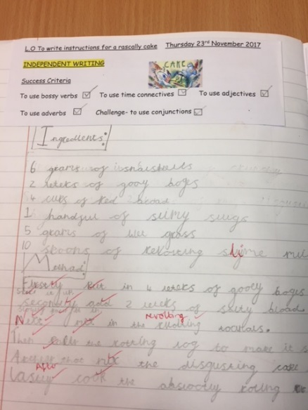  Year 2 | 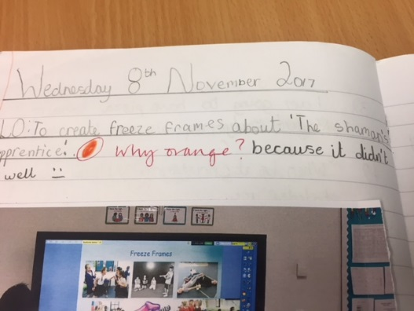  Year 4
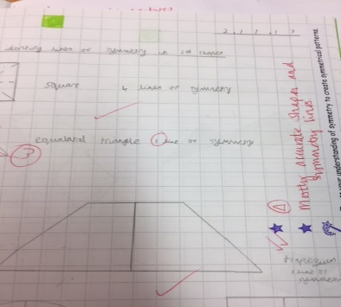  Year 4 | 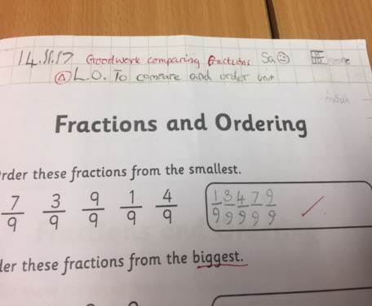  Year 6

All change!
Plans have been announced by Justine Greening, the Education Secretary for the DfE, for a primary assessment system that focuses on pupil progress, mastering literacy and numeracy, and reducing excessive workload for teachers.
The new primary assessment plans aim to deliver a better foundation for measuring progress and the impact of schools.

The Early Years Foundation Stage
The seven areas within EYFS will remain unchanged as will the number of Early Learning Goals underpinning the framework. However, there will be a review of the number of ELGs assessed at the end of reception as well as a review of the descriptors to bring them more in line with Key Stage 1. Moderation procedures will also be reviewed. Any changes will come into effect from the 2020/21 academic year.
Reception Baseline
New reception baseline is to be introduced from 2020. This will be developed, tested and evaluated with a view to introducing it in reception by autumn 2020, with assessments taking place in the first half of the autumn term. There will be a single supplier for this new assessment. The primary focus of the new assessment will be on skills that can be reliably assessed and which correlate with attainment in English and mathematics at the end of Key Stage 2. The outcomes of the assessments will only be used seven years later to make the progress measure at the end of primary school. The academic year 2026/27 (current 1 year-olds) will be the first year progress will be measured from Reception rather than KS1. In the interim years, KS1 assessments will continue to be used as the baseline assessment for measuring progress at Key Stage 2.
Key Stage 1 assessment
The KS1 Grammar, Punctuation and Spelling test will remain optional. Statutory Assessment will remain until at least 2023 in order for a year of overlap with the first cohort to be assessed using the Reception baseline. After 2023, tests and statutory teacher assessment will become optional for primary schools.
Key Stage 2 assessment
Multiplication tables check will be introduced in 2019/20 for year 4. School level data on this won’t be published.
The statutory requirement for schools to report teacher assessment judgements in reading and mathematics will be removed from the academic year 2018-19.

