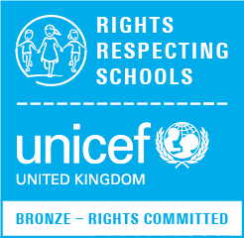
Harlyn School Steering Group Newsletter April 2018

Our school started to work towards the UNICEF Rights Respecting Schools Awards in January 2017. By July 2017, we had achieved our Recognition of Commitment which is now called the Bronze award. We are now working towards our Silver Award.

The Rights Respecting Schools Awards focus on the UN Convention on the Rights of the Child. The Convention says what countries must do so that all children grow as healthy as possible, can learn at school, are protected, have their views listened to, and are treated fairly.
Why do we have rights?
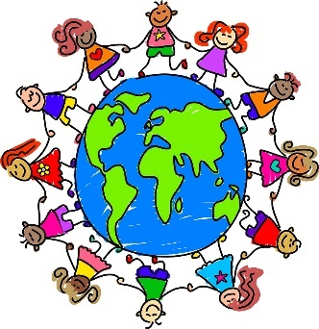
- We have rights because it helps make the world a better place for children and adults.
- Another reason we have rights is because it helps us keep the environment clean and us safe from the dangers of the world.
- Rights are important to us because if we didn’t have them, the world would be an unfair place to live in.
- Even though we have rights, a lot of children in the world are not currently receiving them so this is why UNICEF helps children all around the world.
There are 54 articles in the Rights of a Child. These are some examples of the rights:
Article 4: Governments must do all they can so children enjoy their rights.
Article 24: Every child has the right to the best possible health (e.g a clean environment, good quality health care, clean water and nutritious food).
Article 28: The right to an education.
Article 30: The right to use the languages, religion and customs of your family.
Article 31: The right to relax and play.


Article 12: Every child has the right to have a say in all matters affecting them and to have their views taken seriously.
We asked some of the teachers what they thought about children’s rights.
Mrs Dean:
I am very passionate about children learning about their rights because it helps children understand how they are entitled to live a healthy lifestyle, be treated equally and have the right to share their views. It also helps them develop their understanding about other children and helps create empathy towards others.

Mrs Ivory:
Everyone has the right to an equal chance in life and it should start from an early age! Children will soon be the future adult generation and if their views are mutually respected, then they will feel valued, which in turn will make a better society.
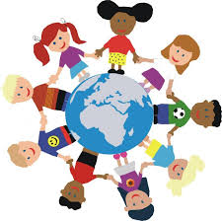
Miss Lack:
It is important for children to learn about their rights so that they can develop their own understanding and share their ideas with others to promote positive outcomes for all based on mutual respect. Understanding your rights can also help with problem solving.
Mrs Mistry:
One of the rights I feel is very important is Article 31: the right to relax, play and take part in a wide range of cultural and artistic activities. This is because it is another opportunity to learn new things about themselves and about the world.

Look at the School Council page on the Harlyn website to find out more about children’s rights.

Created by the Steering Group: Yosur 4D, Ella 4D, Una 4D, Marcus 4B, Akanksha 4B, Ruby Beau 5IM, Devonté 5L, Arissa 5L, Vinay 5IM.

