Curriculum Committee, notes on meeting held 30th June 2022, commencing 4.00 pm
Present: Chris Spratt, David Fox, Murray Perkins, Pedro Borelli, Mike Simons
Policies:
An updated English Policy was approved. Governors were interested to learn about the use of tinted or coloured paper in exercise books and printed texts, also coloured overlay sheets, for children who had difficulty in reading and writing because of optical issues (visual stress) which make it hard to see the letters clearly.
An updated Positive Behaviour Policy was approved. Governors were interested to learn about a scheme whereby children monitored their own mood state as an aid to being aware of their own behaviour.
Three further policies could not be considered in the time available, and it was agreed that committee members would send their comments by email to Chris Spratt later. They are E-safety, Modern Foreign Languages (French), and Ethnic Minority Achievement policies.
Pupil Assessment:
Chris commented that in most cases, the percentage of children working at a level either at the expected standard for their age or above has increased.
The percentage of targets achieved per pupil has generally remained consistent across the three terms and shows an improvement compared to data from the previous academic year.

The percentages of pupils achieving expected or greater than expected progress at this Spring term stage were as follows with the previous term’s numbers shown in brackets, black, and 2021 summer results in brackets in blue. Also for comparison, the last pre-covid year, 2019, in mauve.
Year 1, 52% Reading, 42% Writing, 72% Maths (48, 55, 48%) (64, 44, 60%) (92, 85, 87%)
Year 2, 77% Reading, 66% Writing, 75% Maths (74, 55, 72%) (70, 43, 52%) (75, 65, 78%)
Year 3, 62% Reading, 42% Writing, 40% Maths (64, 12, 38%) (70, 32, 48%) (85, 68, 67%)
Year 4, 75% Reading, 72% Writing, 83% Maths (75, 71, 83%) (53,41,35%) (81, 81, 75%)
Year 5, 64% Reading, 47% Writing, 46% Maths (45, 44, 36%) (37,34, 17%) (88, 87, 81%)
Year 6, no data, awaiting SATS results
In years 3 and 5, substantial numbers of children scored only just below the expected standard, just small improvements needed to reach the expected standard.

Comparison of internal assessment vs NFER tests
For years 1,3,4 and 5, pupils did tests from the National Foundation for Education Research (NFER). The results, below, showed good agreement in many cases, while in others the internal Harlyn data showed lower scores than the NFER tests. The conclusion is that the Harlyn assessments are quite rigorous, and do not deliver over-optimistic scores, and in some cases deliver the opposite.

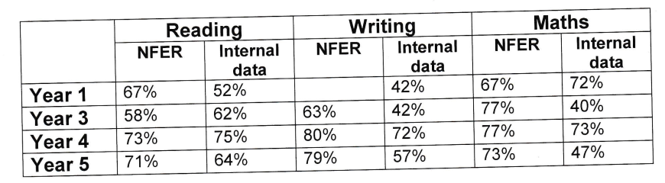
Covid Catch-up measures:
The dedicated catch-up teacher continues to deliver very good results and the system adopted by Harlyn seems more effective than the piecemeal after-school extra lessons adopted by some neighbouring schools. The report is reproduced here.
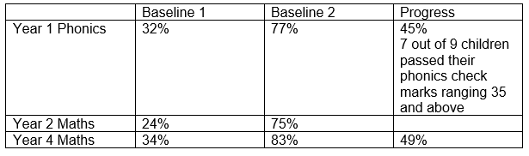
Year 3 – Writing (Children are taken out everyday during their English sessions)
Baseline 1: The children were able to create stories by adding detail such as conjunctions, adverbs, powerful vocabulary and correctly using inverted commas in speech.
Baseline 2: At the end of the block session, the children are writing using imperative verbs, present perfect tense, fronted adverbials and expanded noun phrases.
Year 5 – Writing/SPaG
Baseline 1: The children were creating stories by using basic vocabulary and not correctly using basic punctuation such as capital letters and full stops.
Baseline 2: At the end of the block session, the children are ale to up level their work by using expanded noun phrases and add detail to their writing to create atmosphere with word mats. The children are still working on their basic punctuation skills and grammar terms
Year 6 – Maths
During the final months of SATs prep I supported in class and took the children out, four times a week to work on arithmetic and problem solving skills. Throughout these sessions I was able to target the areas children struggled with and support with different strategies.

Michael Simons (Chair, Curriculum Committee) July 2022

